Aggregate expenditure = GDP = C+I+G+X-M

increase in GDP ⬄ increase aggregate expenditure

Disposable income (YD) = real GDP (Y) – net taxes (T) = spent on consumption goods and services (C) (consumption function) + saved (S) (saving function)

Planned saving = Disposable income – Planned consumption expenditure

Marginal Propensities to Consumption and Save (MPC) = consumption expenditure (DC) / disposable income (DYD)

\*MPC is also the slope of consumption function

Consumption expenditure(C) = aggregate

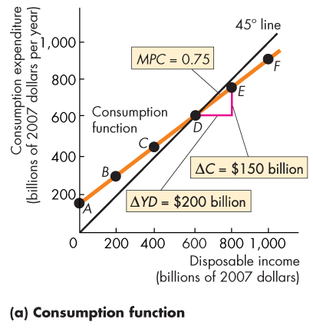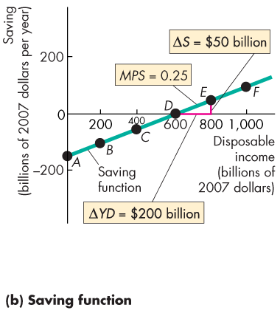

MPC + MPS = 1

Aggregate planned expenditure = planned consumption expenditure + planned investment + planned government expenditure + planned exports – planned imports

Real GDP ^ => planned consumption expenditure & planned imports ^

Planned investment + planned government expenditure + planned exports =

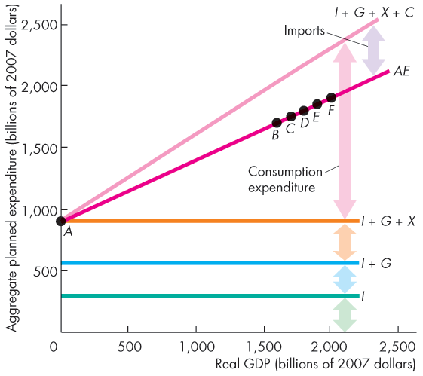

Induced expenditure = consumption expenditure – imports

Autonomous expenditure = investment + government expenditure + imports = real GDP

Equilibrium expenditure: aggregate planned expenditure = real GDP

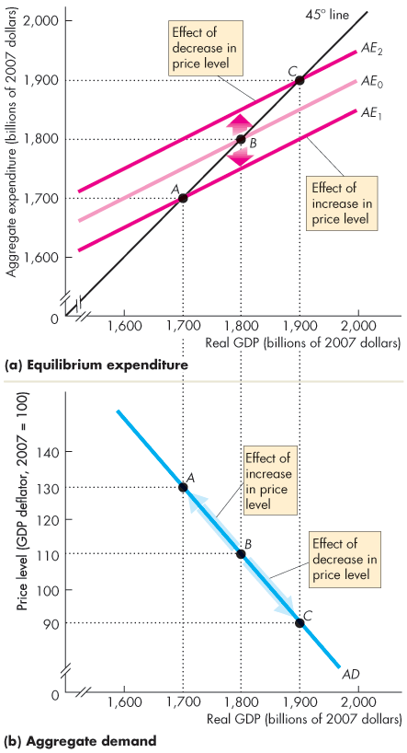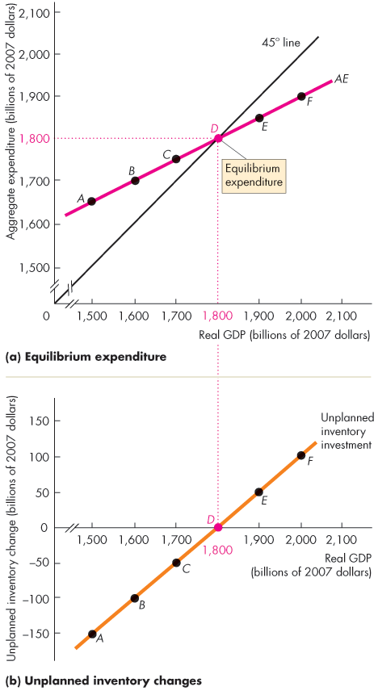

AE curve crosses the 45 line

Decrease/Increase in inventories

Multiplier = 1 ÷ (1 – Slope of *AE* curve)

= Y(GDP) / A (Autonomous expenditure)